SAP SE’s Enterprise Resource Planning (ERP) Review

SAP Enterprise Resource Planning (ERP) is a software suite developed in 1972 by the German company SAP SE. SAP SE is considered the leading company in terms of producing ERP software packages and database software and technology. SAP SE’s ERP influence on the business landscape has shaped the industry standard and allowed major companies such as IBM, Apple to reach their maximum potential and have a global presence. You can consider SAP SE’s ERP to be the nervous system of any company as it helps connect and manage several facets of a company and unify it under one system. Every major company or enterprise can be broken down into several departments which have no relation to each other but do depend on and work with one another to create the company’s product.

For example, if we were to refer to figure 1 and break it down, we would have the following table.

|  |  |
| --- | --- |
| Module | Description |
| Logistics Execution (LE) | SAP Logistics Execution (LE) is a module that focuses on the logistics and supply chain management aspects of an organization. It plays a role in managing and optimizing the movement of goods within and across a company’s network. Everything a company uses with respect to a material or good is dependent on good logistics. If you are unable to properly transport your goods in a timely manner then you will have delays, unfilled quotas and wasted profit. |
| Material Management (MM) | Material Management is responsible for managing the procurement and inventory of raw materials. This module is for companies who create a large amount of product and need to actively track their supplies and sources. Material Management, Logistics and Production Planning go hand in hand. |
| Production Planning (PP) | The Production Planning module helps organizations plan and manage their production processes. It includes features for production scheduling, capacity planning, and bill of materials (BOM) management. With all the material you have and a way to transport it, you now just have to bring it somewhere and begin the production process. This module in tandem with the other two above serve as the foundation of product creation from its beginning as raw materials to its end as the final product. |
| Financial Accounting (FI) | This module is responsible for managing financial data, including general ledger accounting, accounts payable, accounts receivable, asset accounting, and financial reporting. It ensures that financial transactions are accurately recorded and reported. It goes without saying that any product will have its costs and you need to maintain the most cost-efficient way of managing your operation costs and production revenue. |

A few real-life examples that actively use SAP SE’s ERP modules would be from the Bosch and Volkswagen Groups. Bosch has been known to partner and use SAP ERP to manage its materials and production costs while Volkswagen utilizes only their production planning module.

Bosch is an international engineering and electronics company known for producing household goods, industrial technology and automotive parts. The company benefits from SAP's Materials Management (MM) and Production Planning (PP) modules which help optimize inventory management, reducing lead times, and improving production efficiency. Volkswagen, the automobile manufacturer, used SAP ERP's Production Planning (PP) module to optimize its production processes. The module helped Volkswagen improve production scheduling, reduce lead times, and ensure the timely delivery of vehicles to customers. By streamlining production, the company achieved cost savings and increased its production quotas.

But not every system is perfect and the some of the likely pitfalls and shortcomings that I can see with purchasing and using SAP SE’s ERP would be timeline delays, data migration and integration issues. Having a major company migrate from their own system to a brand new one would demand retraining, certification, troubleshooting, verification, validation and more to ensure that everything stays compliant and consistent. While you can set timelines, purchase support options and consultants, delays will always occur, and problems will always arise as you convert your massive organizational system into an unknown equivalent. Especially when you try to integrate some legacy systems that are non-negotiable in terms of conversion, you are left with little space to maneuver and may have to rebuild from scratch. While using SAP ERP may revolutionize how your company approaches, stores, or manages information, you have to consider moving and preserving years of data and work into this new system and hope that nothing gets corrupted, lost or hacked. The easiest proposed solution to any problem is to increase spending and manpower but often is the case where you will either run short on funding or become so bloated that it becomes inefficient.

SAP ERP is undoubtedly revolutionary in terms of enterprise resource planning, it has influenced the field and set the tone for how well a company can be managed through a software package. Regardless of how expansive your company is and how many numerous departments and teams it splits into, you can be assured that there is a module designed for you. With built in integration and a robust set of features, SAP ERP is designed to suit your company’s needs and be able to scale infinitely with the right support. The case in points would be Bosch and Volkswagen groups, internationally recognized suppliers for their respective fields. However, SAP ERP is not perfect and possible shortcomings that are possible would be the loss of data during integration or delays during the integration process. A process that can be done perfectly but nothing is guaranteed. Realistically it all depends on the individuals running the process and how prepared they are for it.

Figure 1

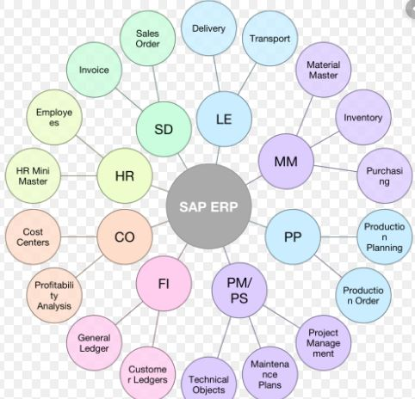

Sources Used:

<https://en.wikipedia.org/wiki/SAP_ERP>

<https://www.investopedia.com/terms/s/sap.asp>

<https://en.wikipedia.org/wiki/Enterprise_resource_planning>

<https://www.investopedia.com/terms/e/erp.asp>

<https://solutiondots.com/blog/sap-erp-modules/>

<https://www.sap.com/products/a-z.html>

<https://en.wikipedia.org/wiki/SAP_S/4HANA>

<https://www.bosch-presse.de/pressportal/de/en/strategic-partnership-bosch-and-sap-aim-to-simplify-corporate-processes-with-a-new-standard-218753.html>

<https://www.sap.com/documents/2022/09/86856191-417e-0010-bca6-c68f7e60039b.html>

<https://erpnews.com/volkswagen-driving-up-standards-in-treasury-management-through-co-innovation-with-sap/>   
<https://aws.amazon.com/solutions/case-studies/vwco/>